

Project Name: Gamer’s Valley System

Branch C-DAC Sept-2022

Documentation On

**“GAMER’S VALLEY”**

C-DAC SEPT 2020

**Guided By: Bakul Joshi**

Submitted By :

**Group No: 19**

* **Amit Kamble 220943020005**
* **Harish Ghadage 220943020035**
* **Vaibhav Shinde 220943020090**
* **Asif Shaikh 220943020083**

**Table of Contents**

**1. Introduction 4**

1.1 Document Purpose **4**

1.2 Project Background **4**

1.3 Aim & Objectives **4**

**2. Business Requirements Overview**…………………………………………………………**5**

**3.Functional Requirements** **5**

3.1 Customer Module **5**

3.2 Distributor Module **5**

3.3 Admin Module **6**

3.4 Expert Module **6**

**4.** **Non-Functional Requirement………………………………………………………………6**

**5. Use Case Diagram 7**

5.1 Admin **7**

5.2 Distributor **8**

5.3 Customer **9**

5.4 Subscribed Customer **10**

5.5 Expert **11**

**6. Database Design 12**

1 Login Table **12**

2 Role Table…….. **12**

3 Question Table……..…………………………………………………………………… **12**

4 Address Table **13**

5 City Table **13**

6 Area Table **13**

7 Customer Table **13**

8 Subscription Table **14**

9 Expert Table **14**

10 Pre-built PC Table **15**

12 Distributor Table **15**

13 Offer Table **16**

14 Category Table **16**

15 Brand Table **16**

16 Order Table **16**

17 Order Item Table **17**

18 Requirements Table **17**

19 Response Table **17**

20 Product Table **18**

**7. E-R Diagram………………………………………………………………………………………19**

**8. Snapshots 20**

**9. Conclusion 28**

**List of Figures**

**Use Case Diagrams 7**

5.1 Admin **7**

5.2 Distributor **8**

5.3 Customer **9**

5.4 Subscribed Customer **10**

5.5 Expert **11**

Fig 6 ER Diagram **11**

1. **Introduction:**
   1. **Document Purpose:**

This document communicates the business requirements and scope for developing Gamer’s Valley System. The scope of this document is to define the functional and non-functional requirements, business rules and other constraints requirements.

## Project Background:

Now-a-days in India gaming industry /esports community is growing wildly. New aspirant gamers are taking gaming as their full-time career. Lots of people still don’t know much about this industry but have interest in gaming and want to enter this industry as a professional gamer or a streamer/entertainer. But they don’t know about which kind of devices they are going to need, which kind of setup is suitable for their starting phase in this journey, and how much financial assurity they will need.

So what people do is, they go the market to buy some gaming PC which is pre-built and has some really high-price, but the problem here is the PC is pre-built, and they cannot modify it according to their interest. So there is no option left for customer to choose the PC parts according to their interest or they don't know much about the PC and in the market as we know, in one shop we cannot get all the things related to our setup.

## Aim & Objectives:

The main objective of this project is to create a web application which will help the aspirant gamers to choose the PC parts according to their interest, according to their profession and to provide a service where customer can find all the necessary devices related to his setup at one place. And to help newly growing gamers to get some information about new devices in the market which will help them out. Providing experts advise to build a perfect PC setup for them is going to be the exceptional part of this application as it going to provide lots of information for growing streamers or gamers. It is user friendly, easy to handle, and requires no maintenance from the user side.

1. **Business Requirements Overview:**

* Gamer’s Valley System is a Web application for aspirant gamers.
* There are mainly four types of users. Admin, Distributor, Expert and Customer.
* Customer can go through different products, buy products and update profile.
* Approving Distributors and Experts, uploading products done through Admin only.
* Expert will upload pre-built PC’s; view requirements received by customers.
* Distributor will upload offers; view orders received from customers.

# Functional Requirements Overview:

Gamer’s Valley System consists of four modules described as below.

1. Customer Module
2. Distributor Module
3. Admin Module
4. Expert Module

# **3.1 Customer Module**

* Gamer’s Valley System provides the functionalities like view products.
* The Customers can add the products to the cart.
* The Customers can view and update his/her profile.

# **Distributor Module**

* Gamer’s Valley System provides the functionality which allows Distributors to upload offers to different products.
* Distributor will be able to see the orders ordered by customers.
* The Distributors can view and update his/her profile.

# **3.3 Admin Module**

* Gamer’s Valley System should provide all functionality to admin how to handle the System.
* Admin has controls of all the functionalities of Distributor and Expert module.
* Admin will add the products which customer is able to buy.
* Admin will approve registration requests from distributor and expert.

# **3.4 Expert Module**

* Gamer’s Valley System provides the functionality which allows Experts to view requirements from the customer to build the customized PC.
* Expert can upload different pre-built PC’s which customers can buy.
* The Expert can view and update his/her profile.

1. **Non-functional Requirement:**

* The website should use professional design, look and feel and color scheme.
* Users will have no limitations for accessing the application through Internet. The portal being an internet application, it is difficult specify exact number of visitor or users. Hence, we will target the system to support between 5 and 10 million users on launch of phase 1.
* Being a public website, the site must follow general usability guidelines for menus, navigation, colors, links and other actions provided on the screens.
* The system should be designed in such a manner that user will be able to complete tasks in minimum number of steps.

.

## 5. Use-Case Diagram

**5.1 Admin:**

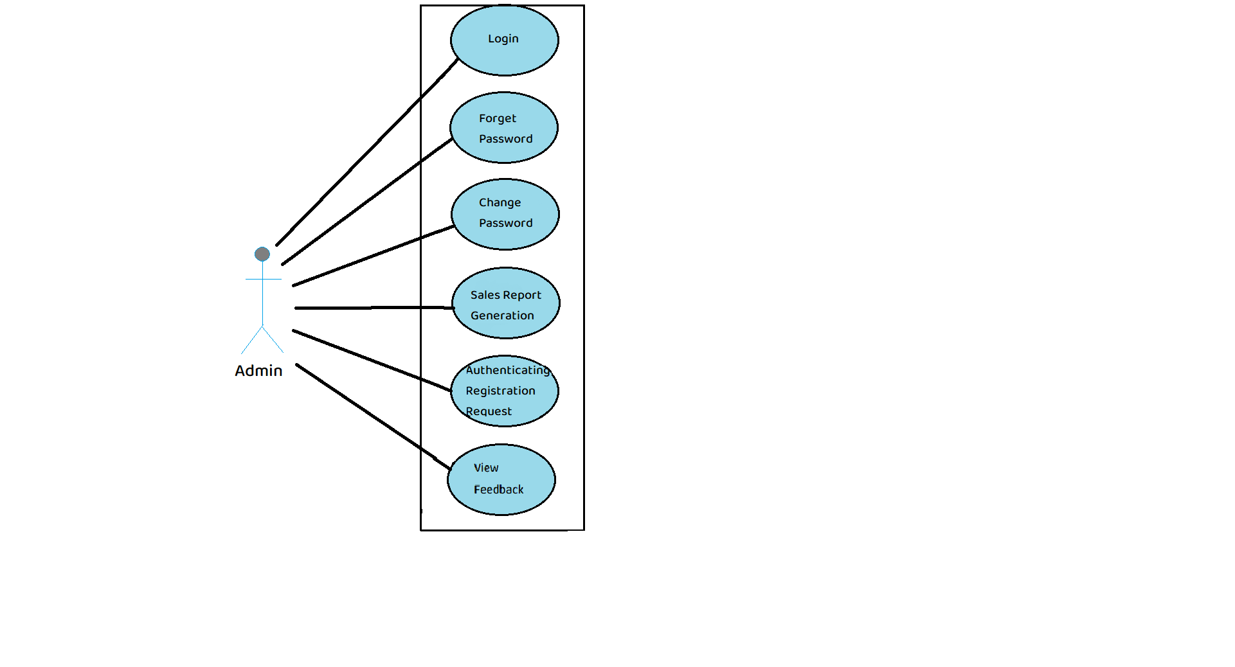

Fig. Use-Case Diagram for Admin

## 5.2 Distributor:

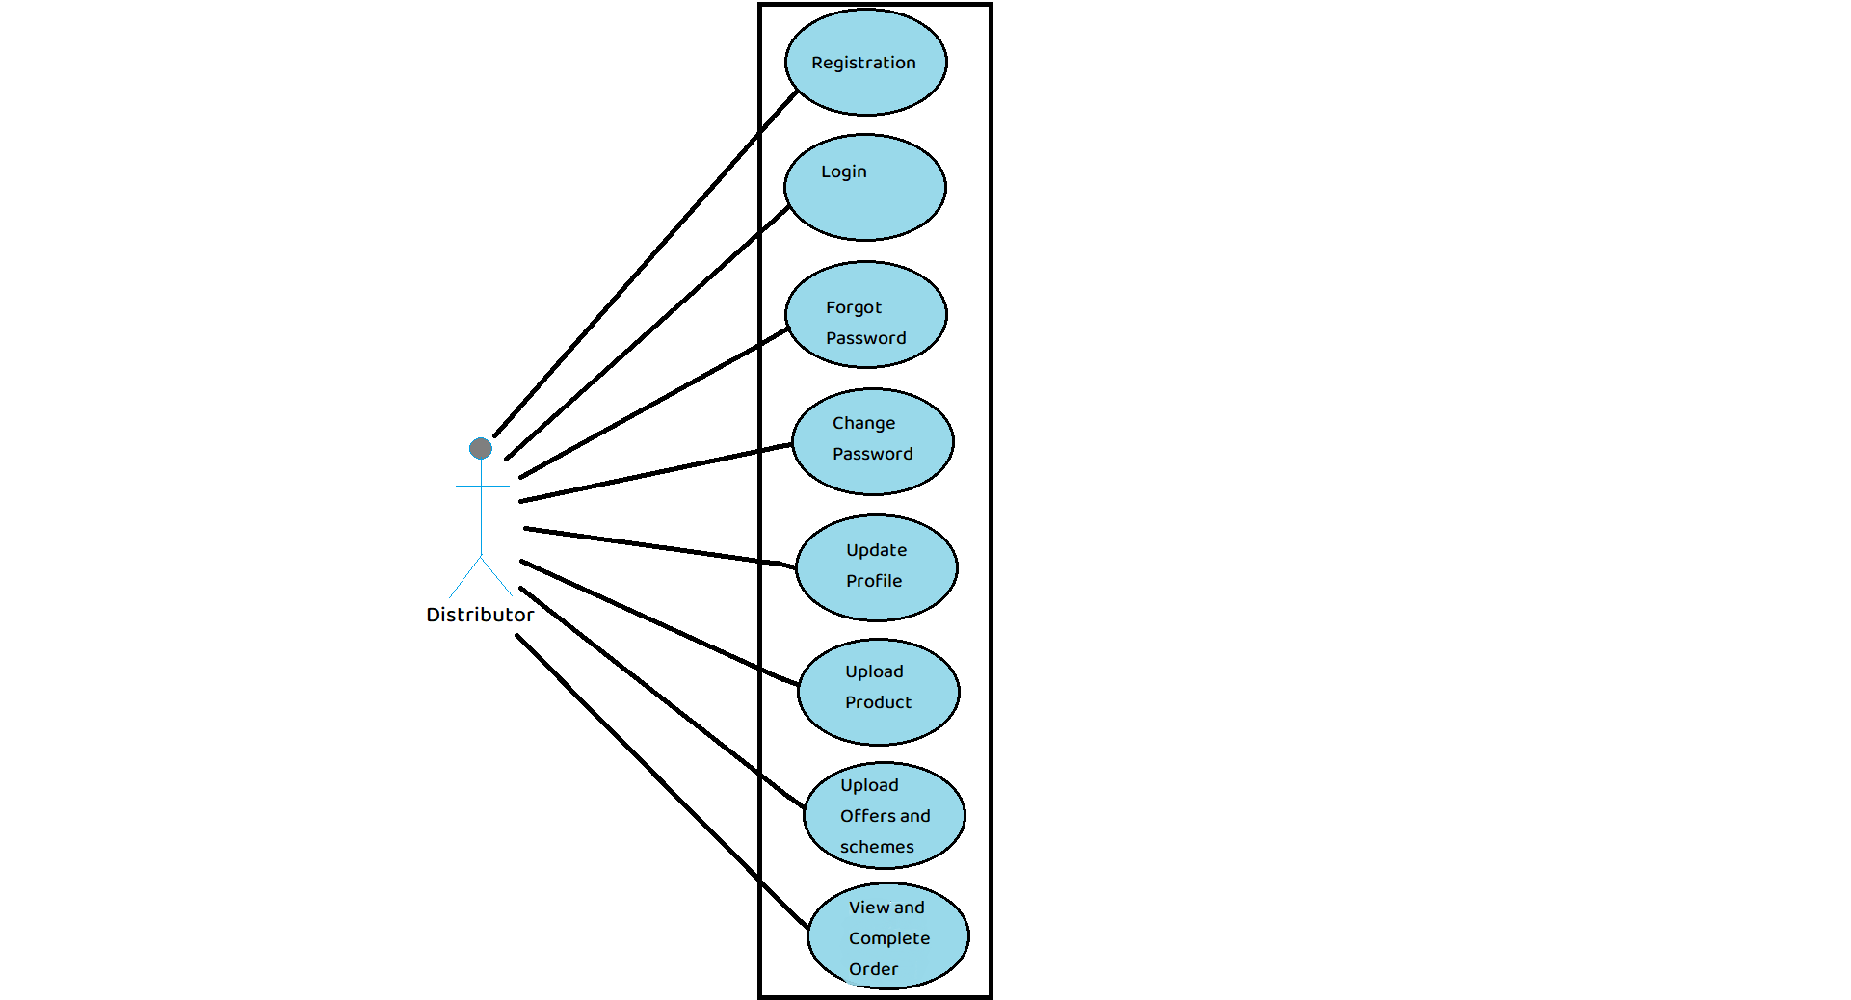

Fig. Use-Case Diagram for Distributor

**5.3 Customer:**  
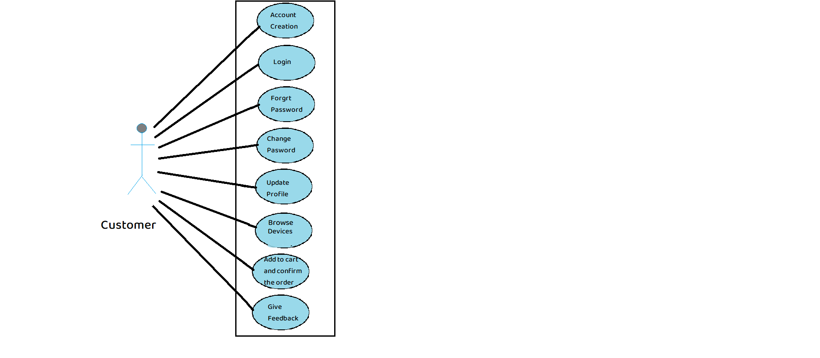

Fig. Use-Case Diagram for Customer

**5.4 Subscribed Customer:**

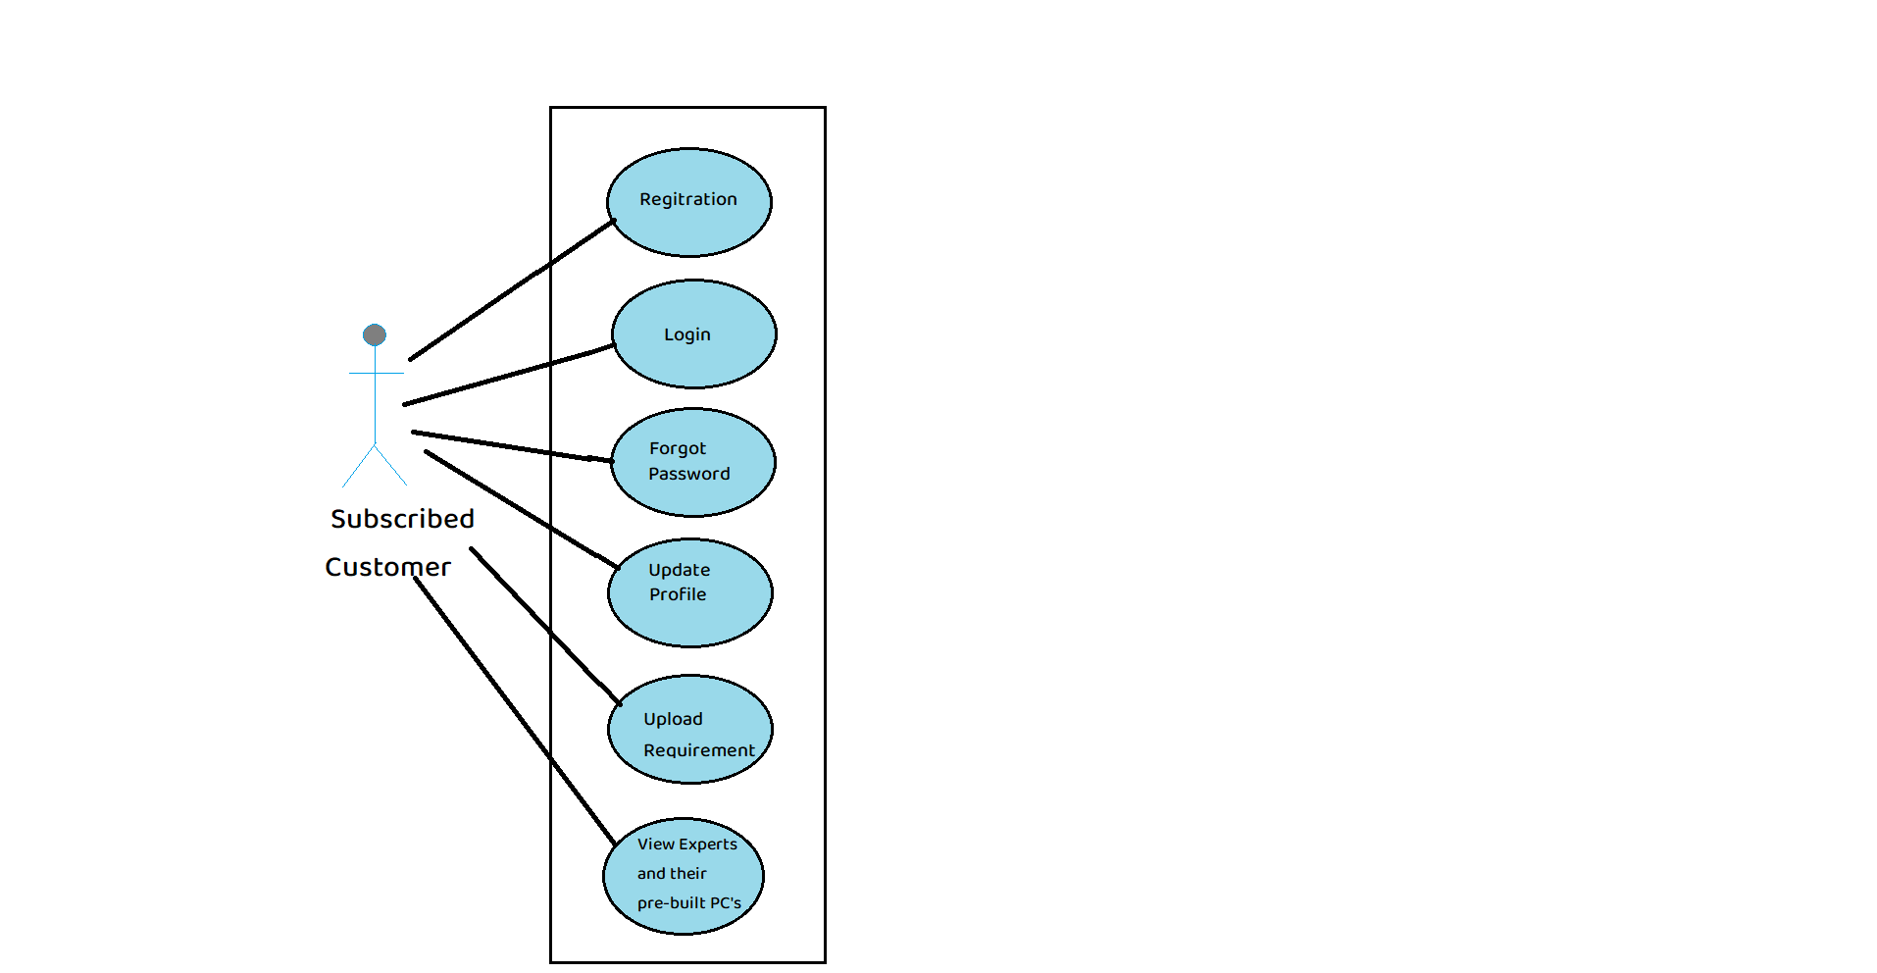

Fig. Use-Case Diagram for Subscribed Customer

**5.5 Expert:**

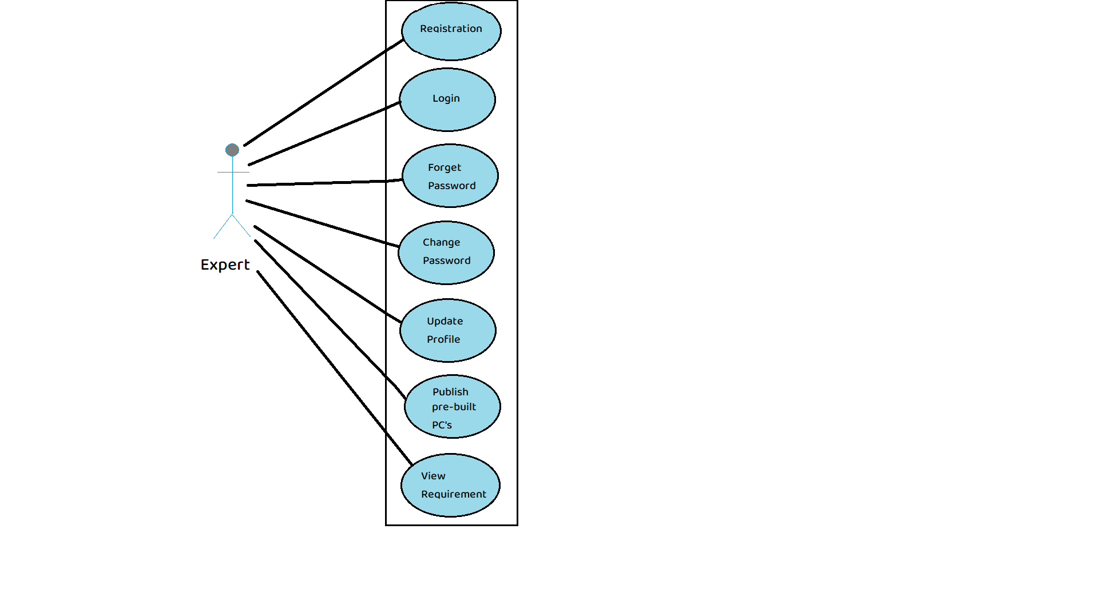

Fig. Use-Case Diagram for Expert

**6. Database Design:**

**1] Login Table**

|  |  |  |  |  |  |
| --- | --- | --- | --- | --- | --- |
| **Field** | **Type** | **Null** | **Key** | **Default** | **Description** |
| login_id | Integer | No | Primary key |  | Login id |
| email | Varchar(45) | No |  |  | Email id |
| pwd | Varchar(45) | No |  |  | Password |
| role_id | Integer | No | Foreign key |  | Role id |
| q_id | Integer | No | Foreign key |  | Question id |
| answer | Varchar(45) | No |  |  | Answer of safety question |
| status | Integer | No |  | 0 | Status for permission |

**2] Role Table**

|  |  |  |  |  |  |
| --- | --- | --- | --- | --- | --- |
| **Field** | **Type** | **Null** | **Key** | **Default** | **Description** |
| role_id | Integer | No | Primary key |  | Role id |
| role_name | Varchar(45) | No |  |  | Role of the person logged in |

**3] Question Table**

|  |  |  |  |  |  |
| --- | --- | --- | --- | --- | --- |
| **Field** | **Type** | **Null** | **Key** | **Default** | **Description** |
| q_id | Integer | No | Primary key |  | Question id |
| q_text | Varchar(45) | No |  |  | Question for security login |

**4] Address Table**

|  |  |  |  |  |  |
| --- | --- | --- | --- | --- | --- |
| **Field** | **Type** | **Null** | **Key** | **Default** | **Description** |
| addr_id | Integer | No | Primary key |  | Address id |
| area_id | Integer | No | Foreign key |  | Area id |

**5] City Table**

|  |  |  |  |  |  |
| --- | --- | --- | --- | --- | --- |
| **Field** | **Type** | **Null** | **Key** | **Default** | **Description** |
| city_id | Integer | No | Primary key |  | City id |
| city_name | Varchar(20) | No |  |  | City name |
| state | Varchar(20) | No |  |  | State name |

**6] Area Table**

|  |  |  |  |  |  |
| --- | --- | --- | --- | --- | --- |
| **Field** | **Type** | **Null** | **Key** | **Default** | **Description** |
| area_id | Integer | No | Primary key |  | Area id |
| area_name | Varchar(20) | No |  |  | Area Name |
| city_id | Integer | No | Foreign key |  | City id |

**7] Customer Table**

|  |  |  |  |  |  |
| --- | --- | --- | --- | --- | --- |
| **Field** | **Type** | **Null** | **Key** | **Default** | **Description** |
| cust_id | Integer | No | Primary key |  | Customer id |
| fname | Varchar(20) | No |  |  | First name of the logged in person |
| lname | Varchar(20) | No |  |  | Last name of the logged in person |
| mobile | Integer | No |  |  | Mobile number of logged in person |
| addr_id | Integer | No | Foreign key |  | Address id |
| bdate | date | No |  |  | birthdate of the logged in person |
| user_status | Integer | No |  | 0 | Type of the customer logged in |

**8] Subscription Table**

|  |  |  |  |  |  |
| --- | --- | --- | --- | --- | --- |
| **Field** | **Type** | **Null** | **Key** | **Default** | **Description** |
| sub_id | Integer | No | Primary key |  | Subscription id |
| cust_id | Integer | No | Foreign key |  | Customer id |
| payment_date | Timestamp | No |  |  | Date and time of the payment |
| Payment_mode | Varchar(40) | No |  |  | Mode of the payment |
| amount | decimal(9,2) | No |  | 0 | Amount for subscription |
| validity | Timestamp | No |  |  | Expiration date of subscription plan |

**9] Expert Table**

|  |  |  |  |  |  |
| --- | --- | --- | --- | --- | --- |
| **Field** | **Type** | **Null** | **Key** | **Default** | **Description** |
| exp_id | Integer | No | Primary Key |  | Expert id |
| fname | Varchar(20) | No |  |  | First name of the logged in person |
| lname | Varchar(20) | No |  |  | Last name of the logged in person |
| mobile | Integer | No |  |  | Mobile number of logged in person |
| addr_id | Integer | No | Foreign key |  | Address id |
| bdate | date | No |  |  | birthdate of the logged in person |
| certification | Varchar(45) | No |  |  | certification of expert |
| experience | Integer | No |  |  | Experience of expert |

**10] Pre-built PC Table**

|  |  |  |  |  |  |
| --- | --- | --- | --- | --- | --- |
| **Field** | **Type** | **Null** | **Key** | **Default** | **Description** |
| pc_id | Integer | No | Primary key |  | Pc id |
| expert_id | Integer | No | Foreign key |  | Expert id |
| monitor | Varchar(45) | No |  |  | Specifications of the moniter used for building the pc |
| keyboard | Varchar(45) | No |  |  | Specifications of the keyboard used for building the pc |
| cpu | Varchar(45) | No |  |  | Specifications of the cpu used for building the pc |
| motherboard | Varchar(45) | No |  |  | Specifications of the motherboard used for building the pc |
| gr_card | Varchar(45) | No |  |  | Specifications of the graphics card used for building the pc |
| ssd | Varchar(45) | No |  |  | Specifications of the ssd used for building the pc |
| mouse | Varchar(45) | No |  |  | Specifications of the mouse used for building the pc |
| total_price | Varchar(45) | No |  |  | Total price of the pc |

**11] Distributor Table**

|  |  |  |  |  |  |
| --- | --- | --- | --- | --- | --- |
| **Field** | **Type** | **Null** | **Key** | **Default** | **Description** |
| distri_id | Integer | No | Primary Key |  | Distributor id |
| fname | Varchar(20) | No |  |  | First name of the logged in person |
| lname | Varchar(20) | No |  |  | Last name of the logged in person |
| mobile | Integer | No |  |  | Mobile number of logged in person |
| addr_id | Integer | No | Foreign key |  | Address id |

**12] Offer Table**

|  |  |  |  |  |  |
| --- | --- | --- | --- | --- | --- |
| **Field** | **Type** | **Null** | **Key** | **Default** | **Description** |
| offer_id | Integer | No | Primary Key |  | Offers id |
| discount | decimal(4,2) | No |  |  | Discount on product |
| prod_id | Integer | No | Foreign Key |  | Product id |
| validity | date | No |  |  | Validity of offers |

**13] Category Table**

|  |  |  |  |  |  |
| --- | --- | --- | --- | --- | --- |
| **Field** | **Type** | **Null** | **Key** | **Default** | **Description** |
| cat_id | Integer | No | Primary Key |  | Category id |
| name | varchar(20) | No |  |  | Category name |

**14] Brand Table**

|  |  |  |  |  |  |
| --- | --- | --- | --- | --- | --- |
| **Field** | **Type** | **Null** | **Key** | **Default** | **Description** |
| brand_id | Integer | No | Primary Key | Null | Brand id |
| name | varchar(20) | No |  | Null | Brand name |

**15] Order Table**

|  |  |  |  |  |  |
| --- | --- | --- | --- | --- | --- |
| **Field** | **Type** | **Null** | **Key** | **Default** | **Description** |
| oid | Integer | No | Primary Key |  | Order id |
| cust_id | Integer | No | Foreign Key |  | Customer id |
| distri_id | Integer | No | Foreign Key |  | Distributor id |
| date | date | No |  |  | Date of order |
| status | varchar(20) | No |  |  | Status of order |
| pay_mode | Varchar(20) | No |  |  | Mode of payment |
| amt | decimal(9,2) | No |  |  | Total amount of items |
| transaction_id | Integer | No |  |  | Transaction id |

**16] Order Item Table**

|  |  |  |  |  |  |
| --- | --- | --- | --- | --- | --- |
| **Field** | **Type** | **Null** | **Key** | **Default** | **Description** |
| oi_id | Integer | No | Primary Key |  | Order items id |
| oid | Integer | No | Foreign Key |  | Order id |
| prod_id | Integer | No | Foreign Key |  | Product id |
| qty | Integer | No |  |  | Quantity of items |
| price | decimal(9,2) | No |  |  | Price of items |

**17] Requirements Table**

|  |  |  |  |  |  |
| --- | --- | --- | --- | --- | --- |
| **Field** | **Type** | **Null** | **Key** | **Default** | **Description** |
| req_id | Integer | No | Primary key |  | Requirement id |
| cust_id | Integer | No | Foreign key |  | Customer id |
| exp_id | Integer | No | Foreign key |  | Expert id |
| min_price | Integer | No |  |  | Minimum price of the PC |
| max_price | Integer | No |  |  | Maximum price of the PC |
| Specifications | Varchar(45) | No |  |  | Specifications of the PC |

**18] Response Table**

|  |  |  |  |  |  |
| --- | --- | --- | --- | --- | --- |
| **Field** | **Type** | **Null** | **Key** | **Default** | **Description** |
| res_id | Integer | No | Primary key |  | Response id |
| req_id | Integer | No | Foreign key |  | Requirement id |
| status | Integer | No |  |  | status of the response |
| pc_id | Integer | Yes | Foreign key |  | Pc id |

**19] Product Table**

|  |  |  |  |  |  |
| --- | --- | --- | --- | --- | --- |
| **Field** | **Type** | **Null** | **Key** | **Default** | **Description** |
| prod_id | Integer | No | Primary key |  | Product id |
| cat_id | Integer | No | Foreign key |  | Category id |
| brand_id | Integer | No | Foreign key |  | Brand id |
| description | Varchar(45) | No |  |  | Description of the product |

## 7. ER-Diagram:

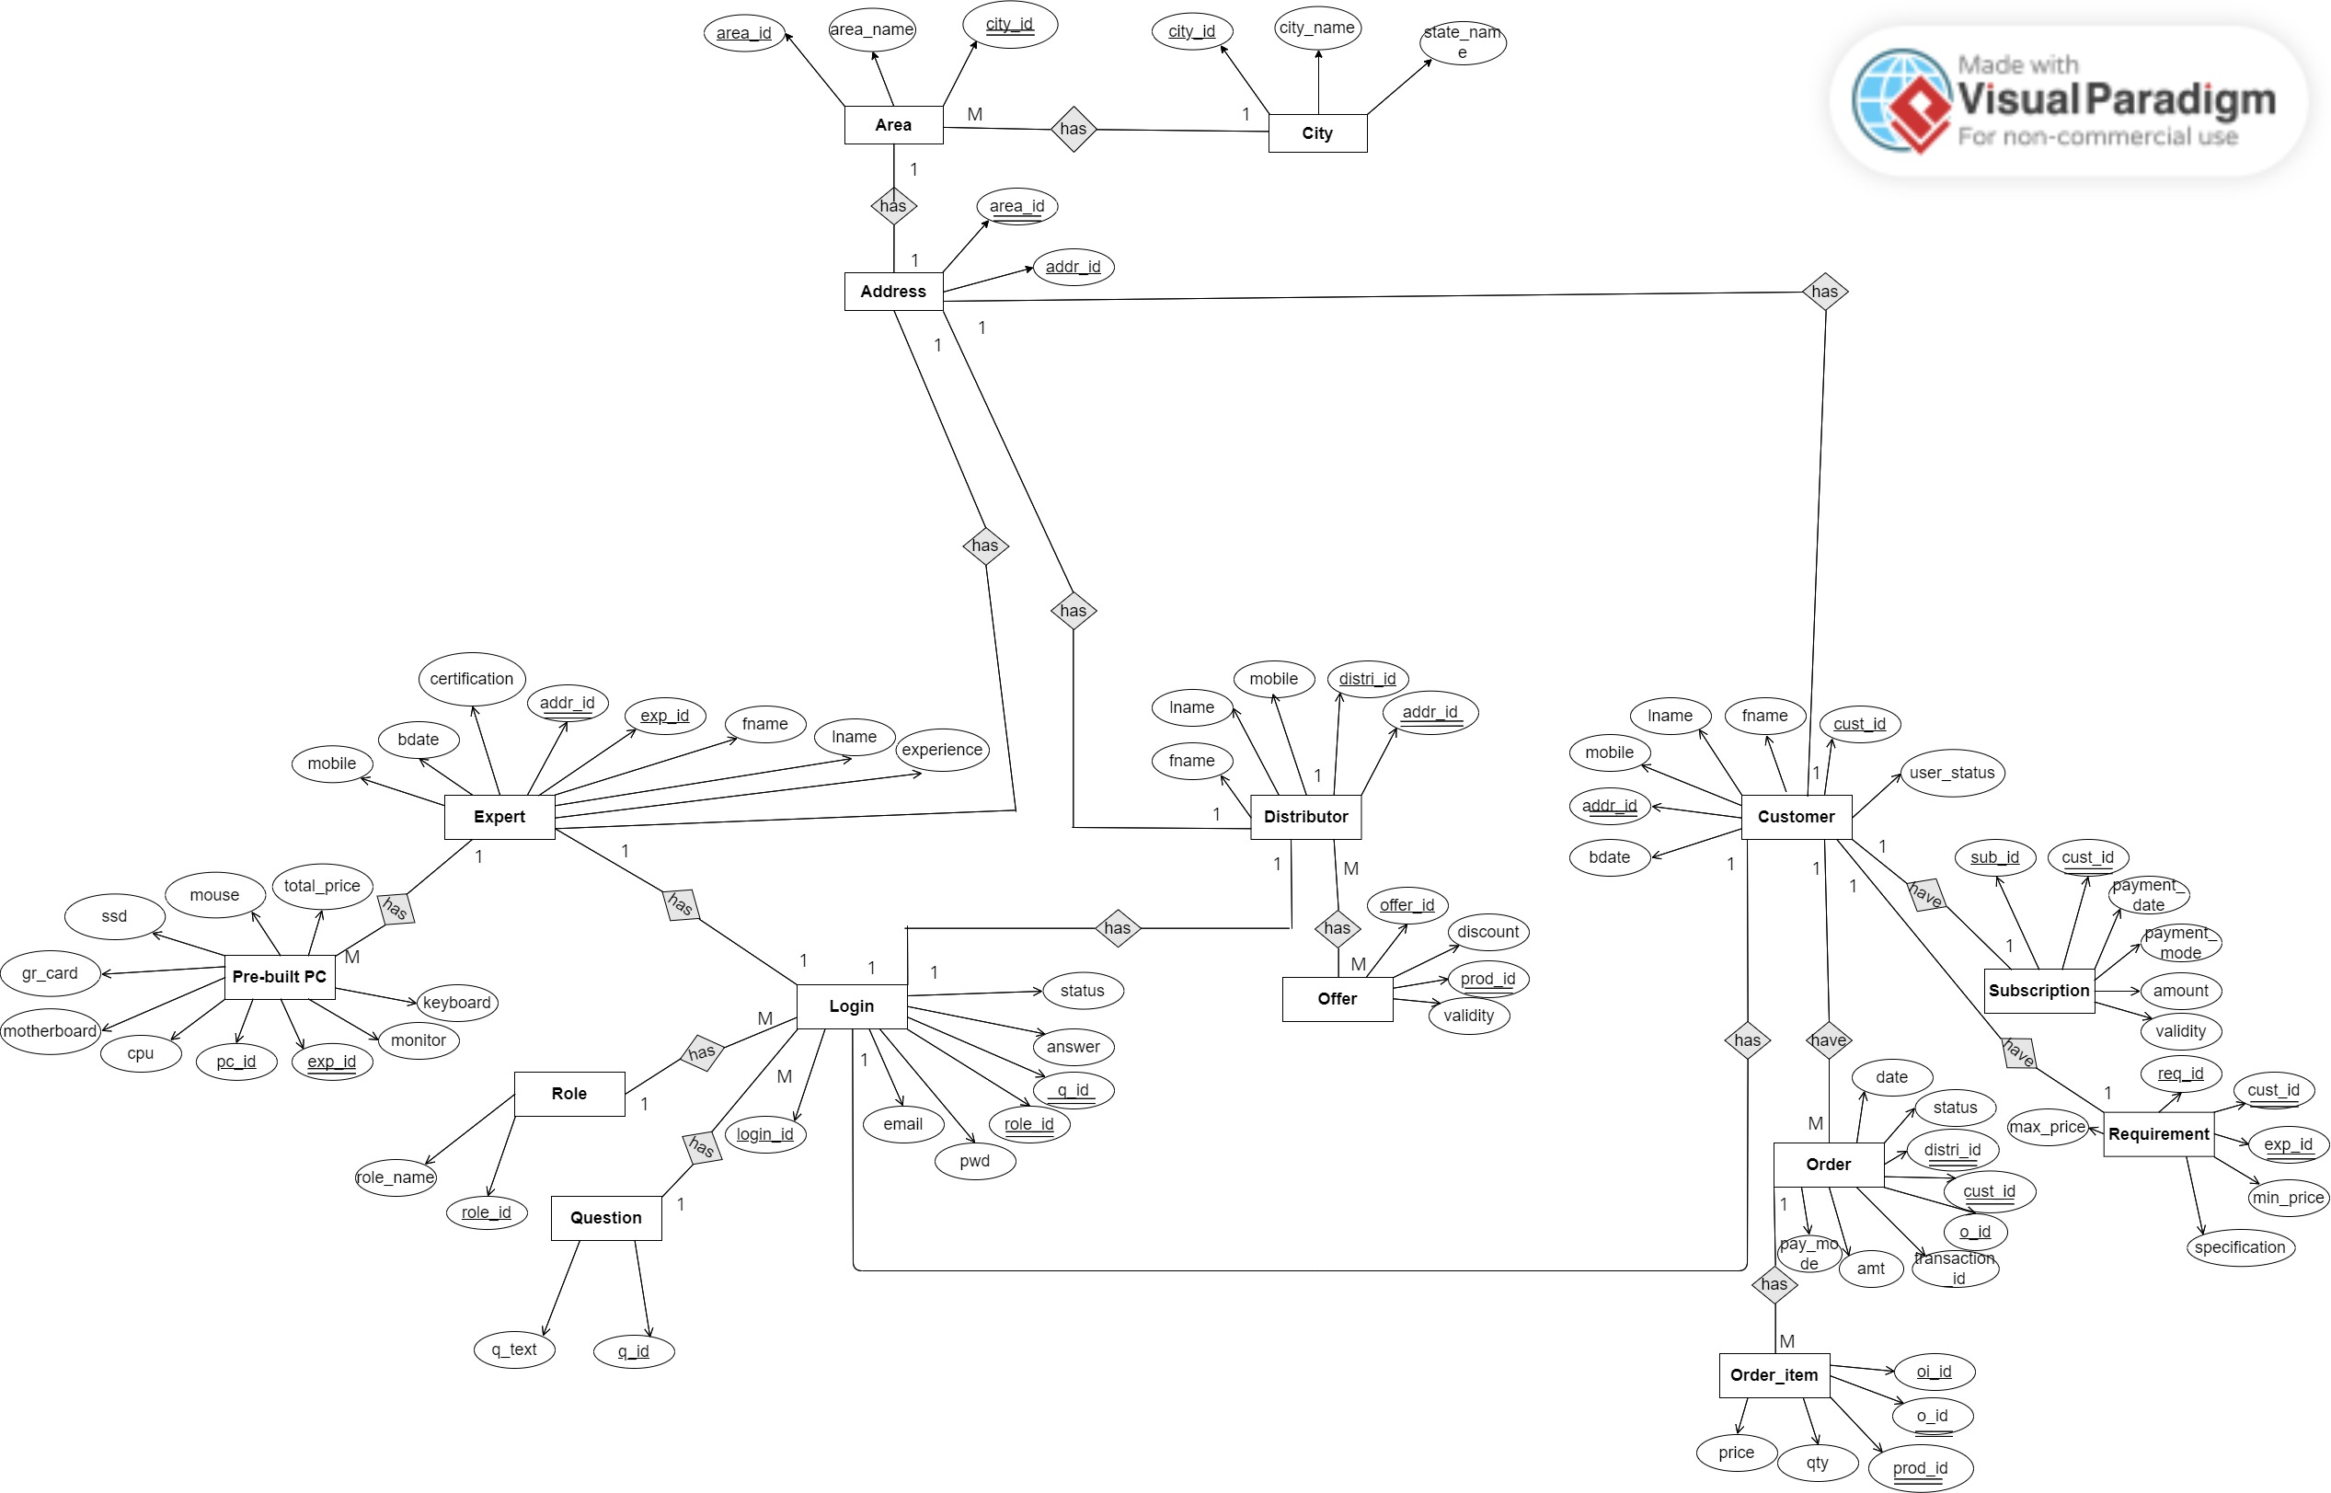

**E-R diagram shows database of Paperless School Management System**

**8. Snapshots:**

**8.1 Home Page:**

Following snapshot shows the Home page for Gamer’s Valley System

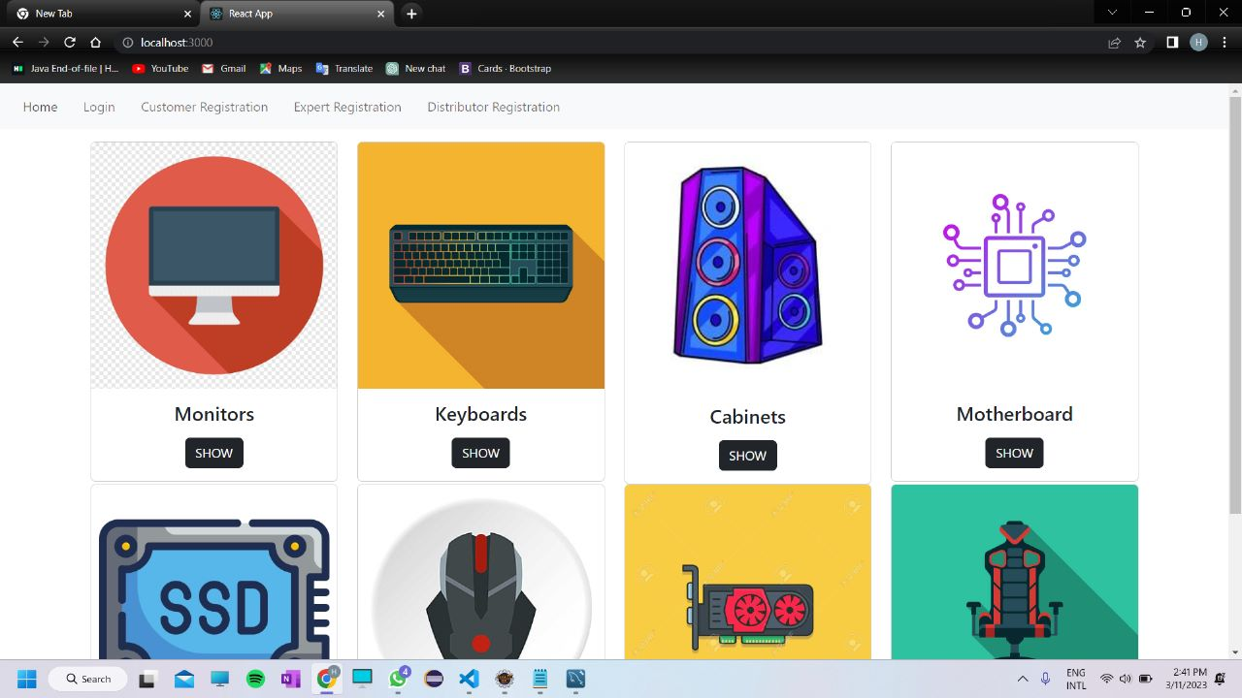

This page contains following controls

* Home
* Registration
* Login Button

**8.4 Login Page**

Following snapshot shows the Login page for Gamer’s Valley System

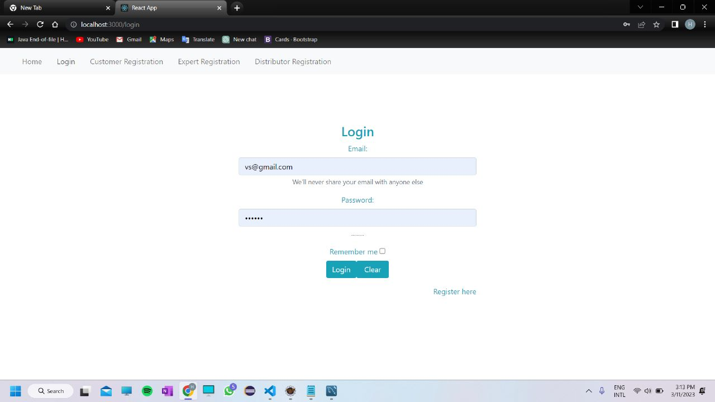

**8.5 Admin Home Page**

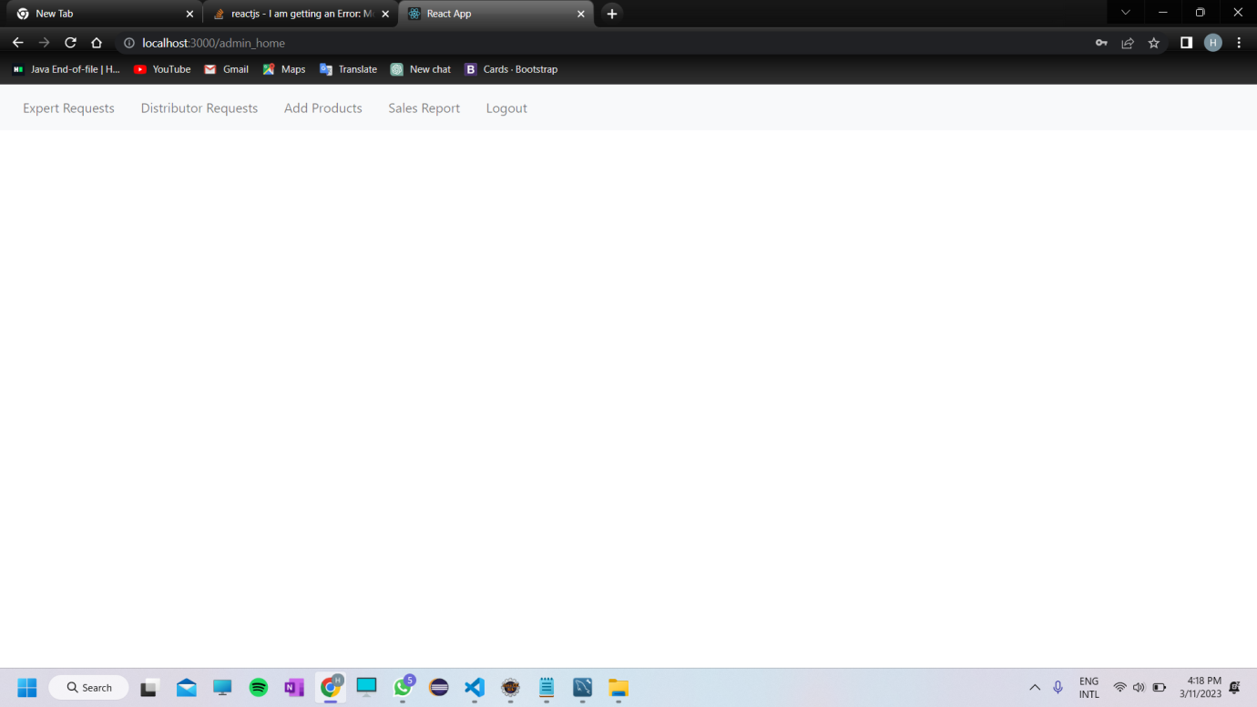

**8.5.1 Expert Request Page**

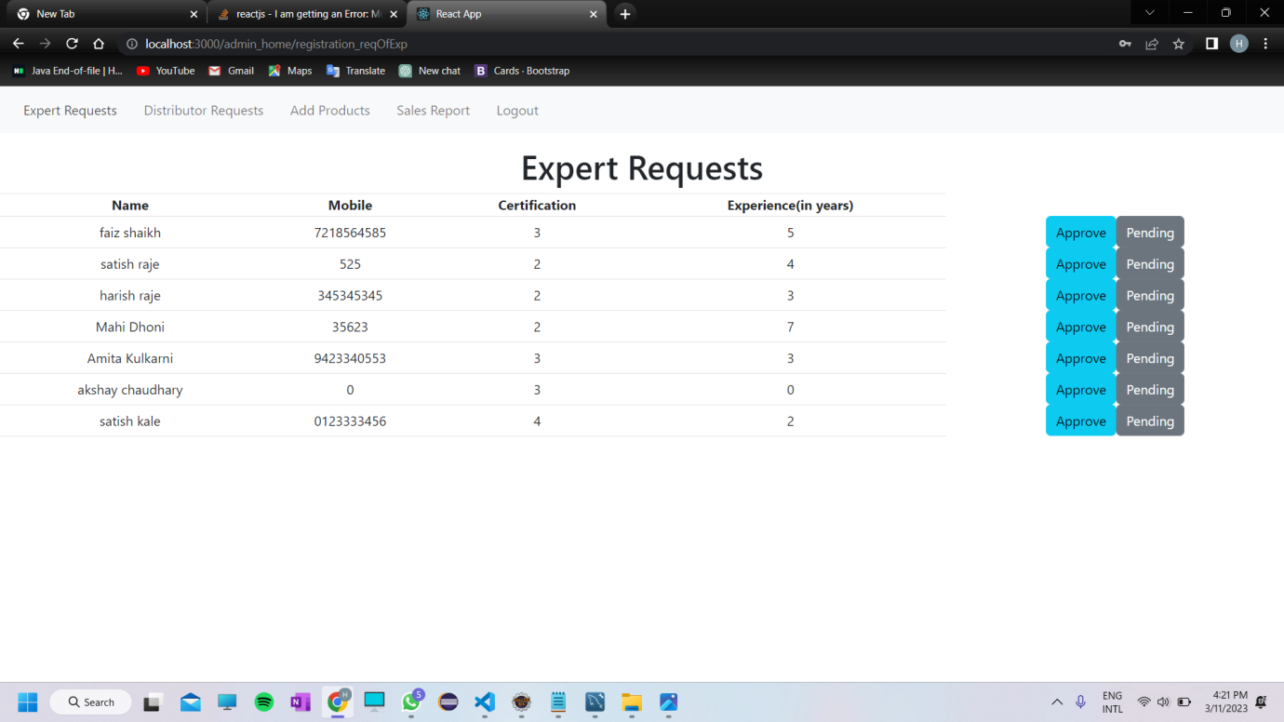

**8.5.2 Distributor Request Page**

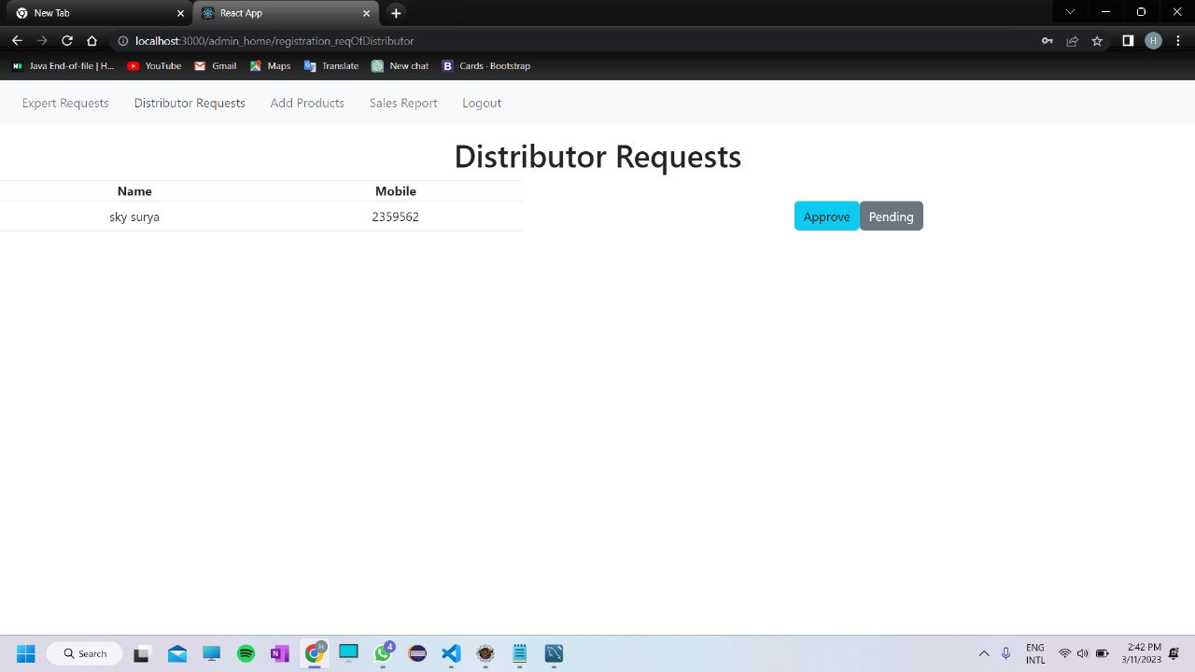

**8.5.3 Add Products**

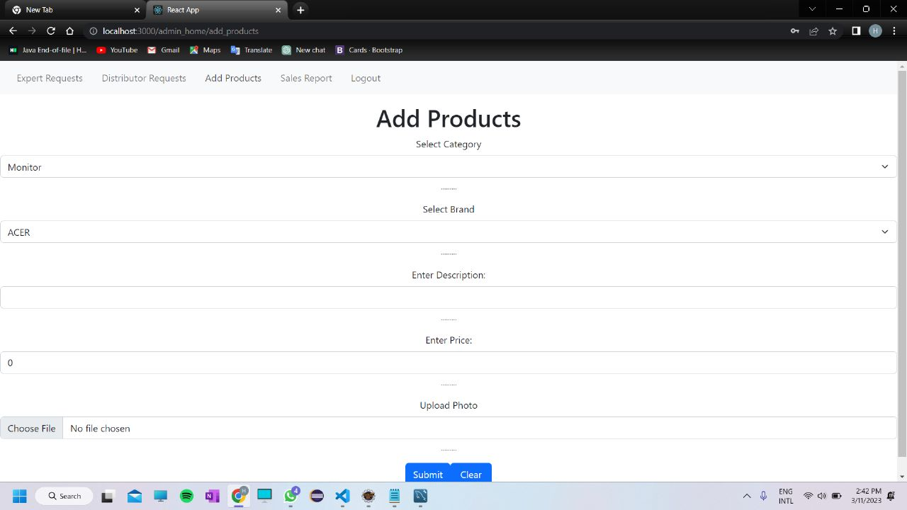

**8.6 Expert Home Page**

**8.6.1 Expert Home Page**

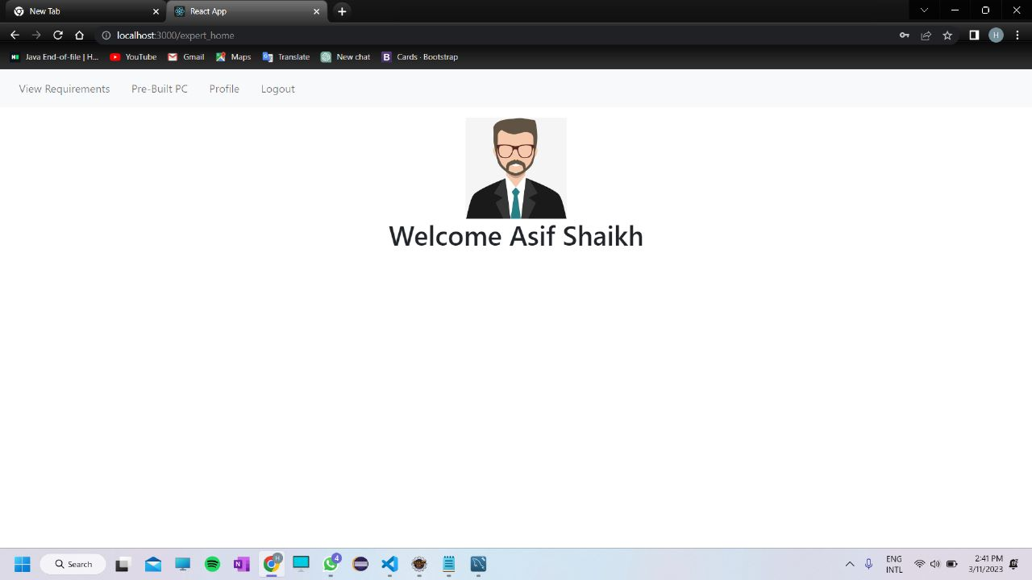

**8.6.2 View Requirements Page**

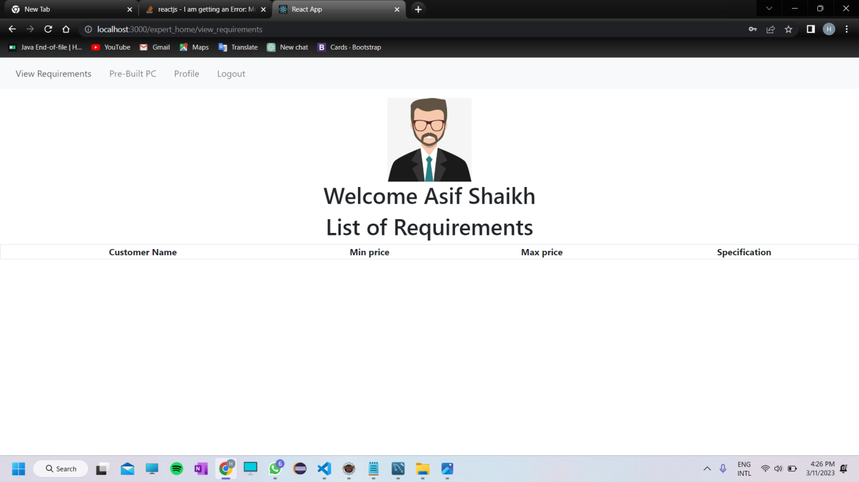

**8.6.3 Prebuilt PC’s Page**

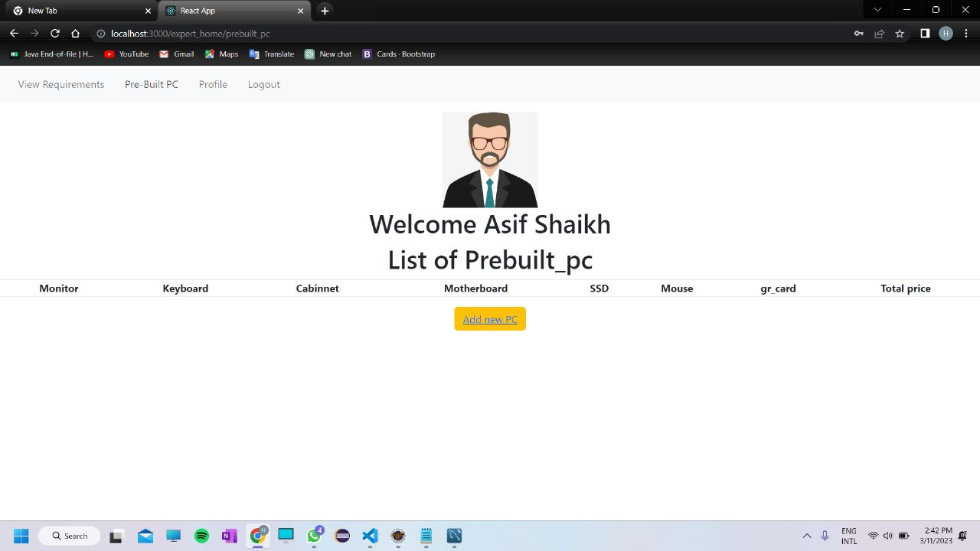

**8.6.4 Update Profile Page**

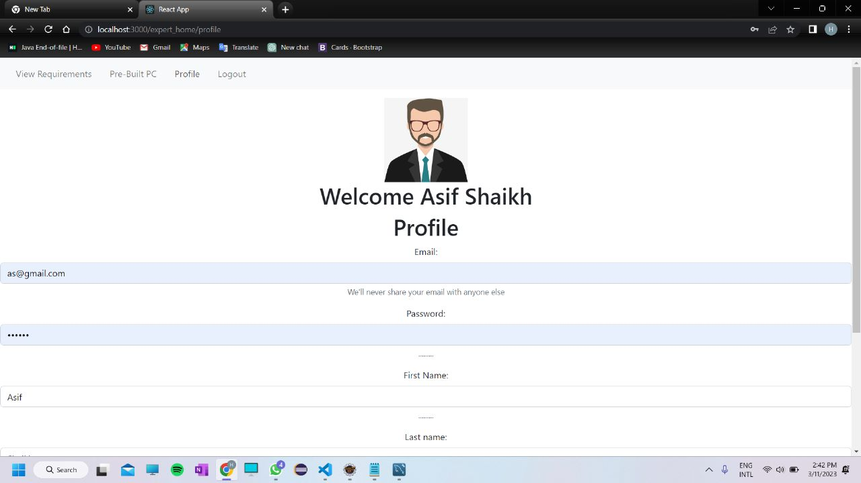

**8.7 Distributor Home Page**

**8.7.1 Distributor Home Page**

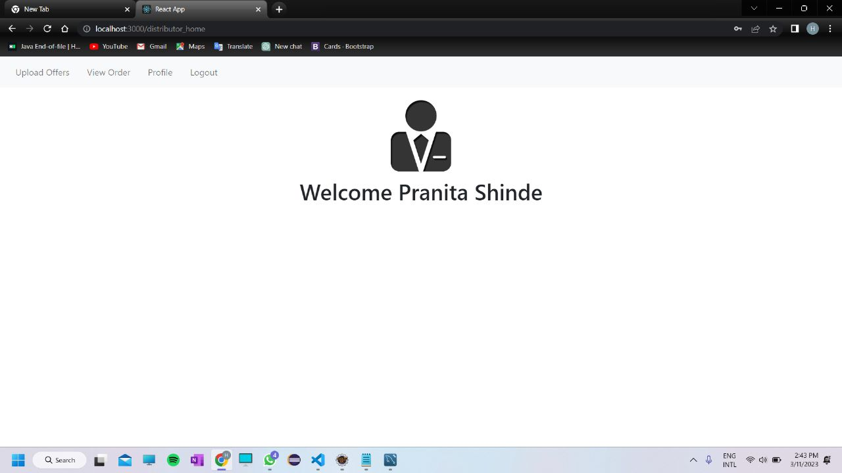

**8.7.2 Upload Offers Page**

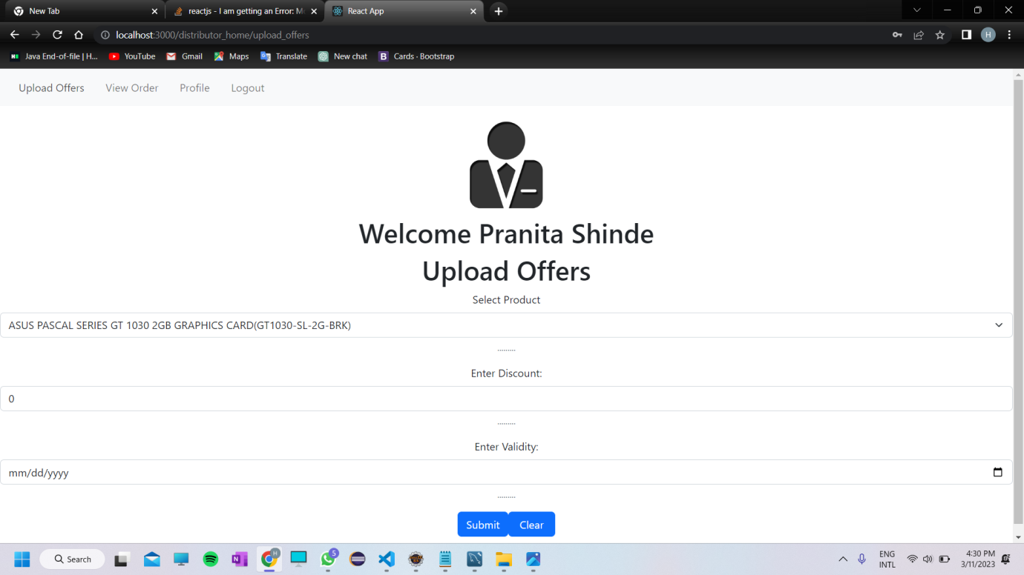

**8.7.3 Update Profile Page**

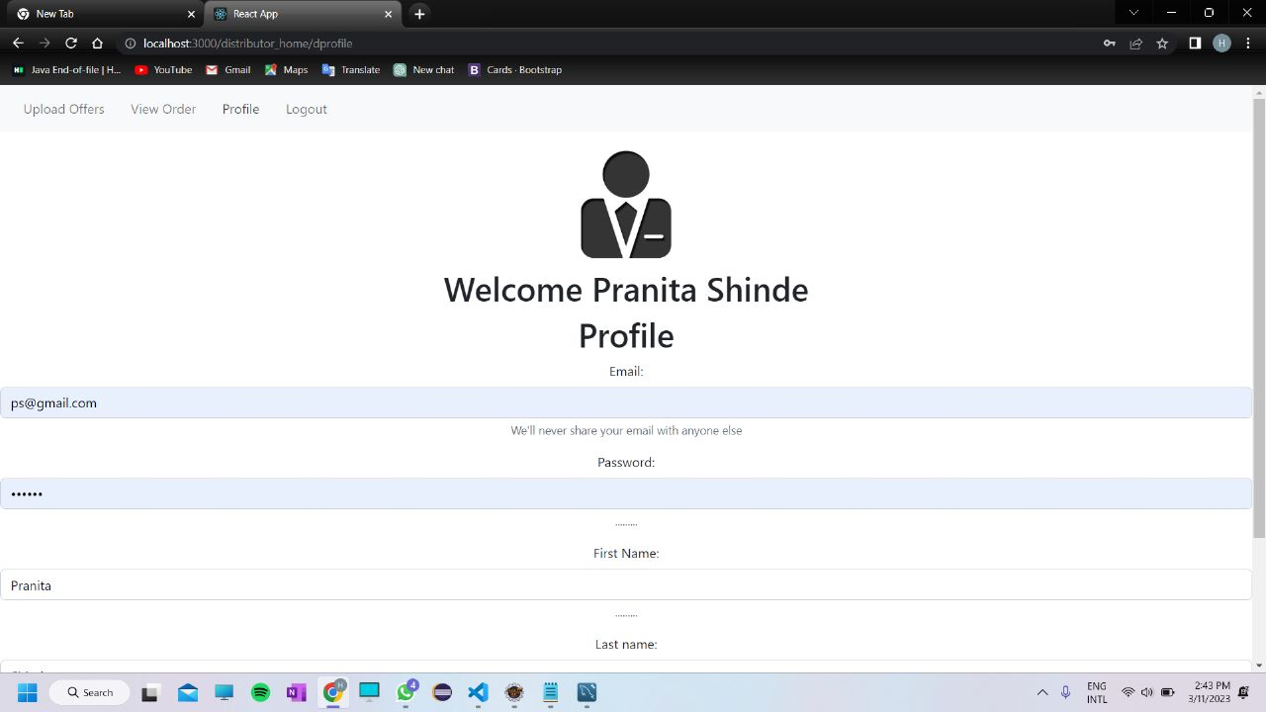

**8.8 Customer Home Page**

**8.8.1 View Products Page**

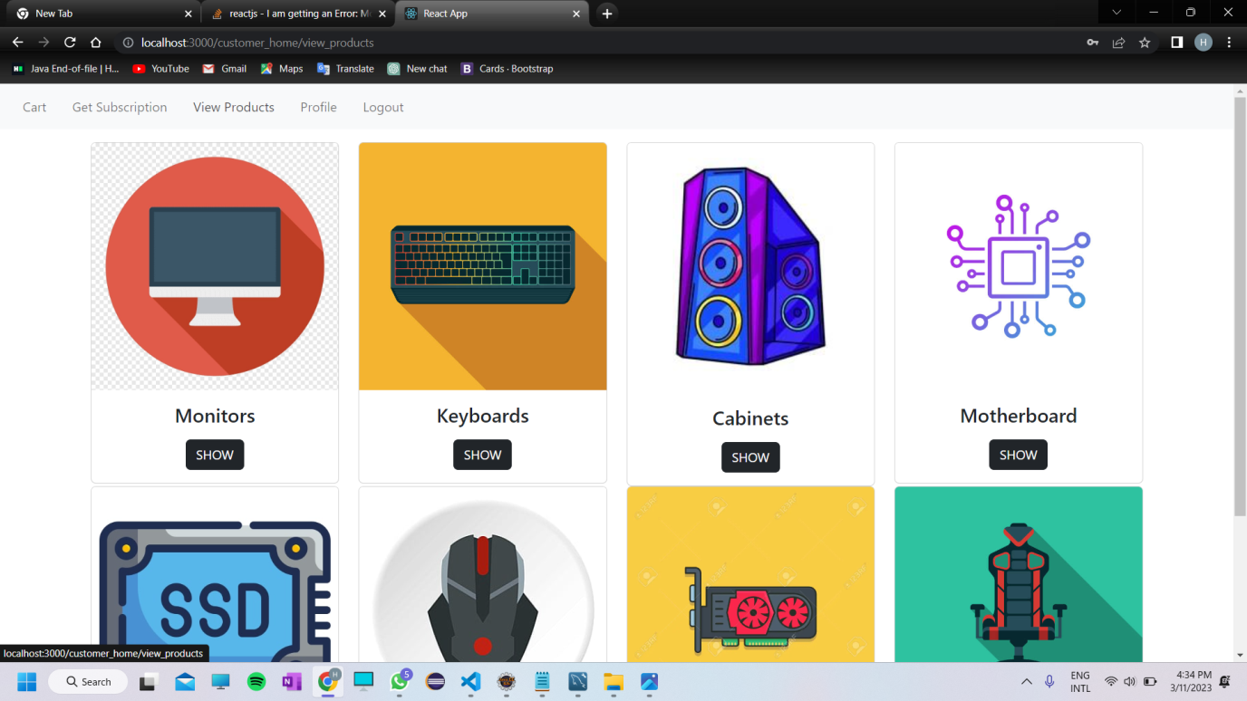

**8.8.2 Update Profile Page**

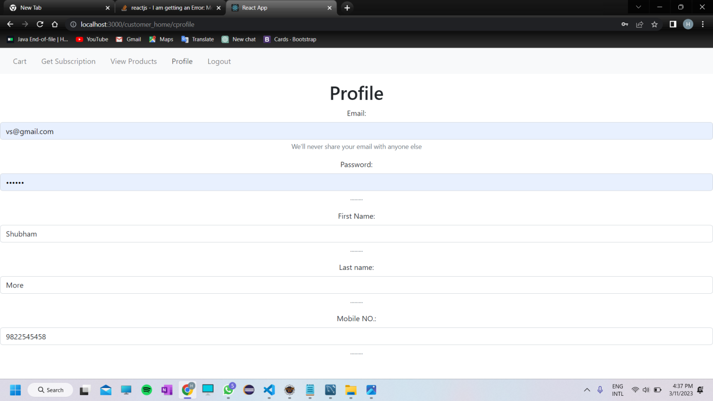

**9. CONCLUSION AND FUTURE SCOPE**

* Gamer’s Valley System provides better platform for gamers to buy the gaming products as per their need.
* Our System provides a very user-friendly platform where gamers can easily buy products as well as get advice from experts about various products needed for their work. Expert can build PC’s according to need of the customer which is a unique feature of gamer’s valley system.
* Providing experts advice is an exceptional part of this shopping application which will help to build a perfect PC setup for aspirant gamers as it going to provide information about customized PCs to them.